Demand Letter against Local Union 28

DATE:
BY E-MAIL
Salvatore Starace
SMART
1750 New York Avenue, NW
6th floor, Washington, DC 20006

Re: Sexual harassment at Local Union 28

Dear Mr. Starace,
We have the tremendous privilege of representing Nia Meltzer in connection with her sexual harassment claims against Local Union 28 in violation of the New York City Human Rights Law (“NYCHRL”) and New York State Human Rights Law (“NYSHRL”).

This letter outlines a series of concerning incidents of sexual harassment at Local Union 28 that transpired through a magnitude of stalking text messages by a coworker requesting sexual favors from Ms. Meltzer.

During Ms. Meltzer's tenure at Local Union 28 working for Delta Sheet Metal, her coworker, Christopher Barba, engaged in a campaign of anonymous harassment through phone calls and messages. Soon after Ms. Meltzer and Mr. Barba exchanged numbers for work purposes, Ms. Meltzer began receiving messages suggesting her to find a “Sugar Daddy.” At this time, Ms. Meltzer was unaware of the sender’s identity.Mr. Barba’s communications quickly escalated to more explicit and unsolicited content. Despite Ms. Meltzer’s decision to cease responding, Mr. Barba persisted, becoming increasingly aggressive and insistent. Mr. Barba eventually began to announce to Ms. Meltzer that he was aware of her movements, by asking about her whereabouts as she returned home from work.
Ms. Meltzer explained her frustrations to personal acquaintances and coworkers, explaining how distressed she was. Ms. Meltzer’s attempt to block Mr. Barba’s number was proved futile, as he continued to harass her using new, anonymous phone numbers.
[Add change of numbers and covid announcement]
Subsequently, Mr. Barba confirmed that Mr. Barba was the one harassing her. When Mr. Barba attempted to send one dollar to Ms. Meltzer via Cashapp, the application advised her that the request was from someone “in your contacts''. As Ms. Melzer already suspected Mr. Barba as the sender, she deleted Mr. Barba’s phone number from her contacts at which pointthe application showed that the Cash App requests came from someone “not in your contacts.” When Mr. Barba wasconfronted by Ms. Meltzer, he admitted he was the one sexually harassing her.
Following Ms. Meltzer’s complaint to Local Union 28 , Mr. Barba was purportedly terminated by Local Union 28. Though the investigation cited termination, Mr. Barba was not terminated and allowed to come back to work contingent on paying abeyance fees to the Union. Clearly, Local Union 28 failed to exercise reasonable care to prevent Mr. Barba from sexually harassing other employees.

.

Ms. Meltzer Begins to Receive Anonymous Text Messages after Exchanging Numbers with Colleagues

II) Despite changing her phone number, Ms Meltzer continues to Receive Text Messages Causing Suspicions of One-Coworker
COVID thing
Xmas party

III) Ms. Meltzer Confirms Mr. Melbas Identity as the Harasser
Cash app
II. Inconsistencies with Findings (Investigation) –
After confirming Mr. Melbas’s identity, police report
---(she reports it to someone in her job) (info we still need from her)

Subsequently, on November 30, 2022, Local Union 28 held a Trial conducted by . Mr. Barba did not appear at the trial though he was required to.

The investigation notes that because Mr. Barba continued to contact Ms. Meltzer while investigation was pending, he was terminated by Delta. However, Mr. Barba remained employed by Local Union 28.

The inconsistencies in the finding of Ms. Meltzer’s case raise significant concern regarding the transparency and the potential for Mr. Barba to return to work at Local Union 28. With Ms. Meltzer’s compelling presentation of screenshots and explicit messages during the Trial Committee proceedings, the Trial Committee did not reasonably correct and prevent Mr. Barba’s behavior. Specifically, thr Trial Committee held Mr. Barba guilty on the following
- three counts rendering him a fine of $30,000- and 26-hours training for sexual harassment.
https://www.smart-union.org/constitution/

There is an apparent discrepancy between Local Union and what Delta didthe initial termination and final disciplinary measures, showing a lack of clarity in the Union’s handling of the situation. Local Union 28 has left open the possibility for Mr. Barba to return to his position. The absence of a definitive stance on his employment status leaves uncertainty which leads to the continued uneasiness Ms. Meltzer feels while at the Local Union.

III. Lack of Termination shows room for Negligence Retention

On August 28, 2021, Ms. Meltzer began to experience harassment from Mr. Barba after exchanging numbers with him for work related purposes. Their interactions were strictly confined to professional contexts, as they had never met outside of a work-related event. Even when Ms. Meltzer changed her phone number, Mr. Barba managed to obtain it due to necessary communication about her Covid status following a work event they had both attended. She explained the unwanted messages, calls, and explicit messages she was receiving to her coworkers.
Despite knowing the extent of the harassment endured by Ms. Meltzer over approximately eight months, Local Union 28 left the possibility open for Mr. Barba’s return. This leniency raises concerns about the union’s commitment to protect its members from harassment. Given Mr. Barba’s prolonged and aggressive behavior, there is a fear that if he is reinstated, he will continue to engage in similar offenses.

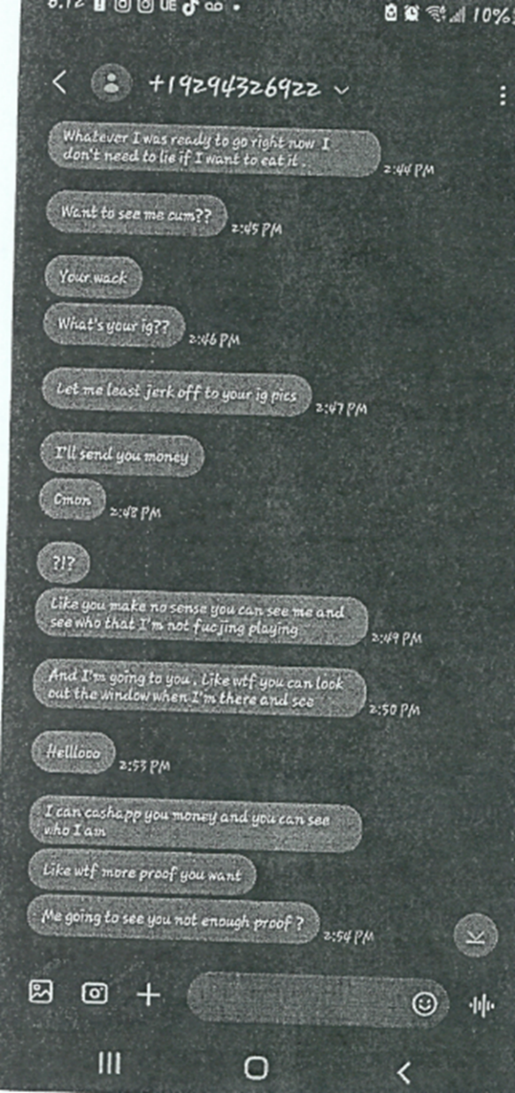

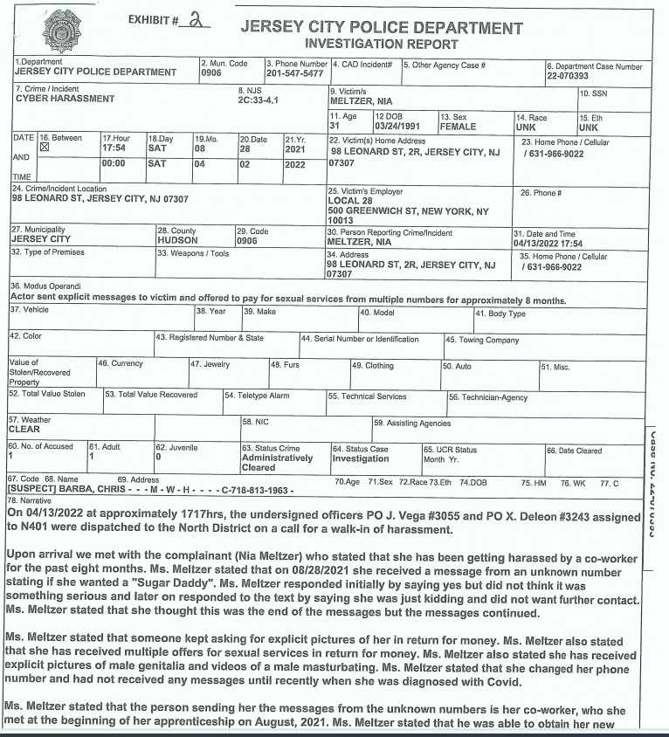

On April 13, 2022, Ms. Meltzer met with the Jersey City Police Department because of the immense amount of harassment she was placed under. By seeking assistance from the police department, shows the impact Mr. Barba’s action had on her well-being.

IV. Local Union 28’s Conduct Violates the Law

This incident illustrates Local Union 28’s continuing disregard for protecting its employees from sexual harassment perpetuated by another one of its employees and mishandling of an employee who was found guilty of these actionsThe lack of protection from Mr. Barba's actions violates the New York State Human Rights Law (“NYSHRL”), and the New York City Human Rights Law (“NYCHRL”).

IV. Conclusion
Our client is genuinely devastated by Local Union 28’s lack of regard and protective measures. Ms. Meltzer committed to achieving complete vindication for the contemptible actions to which she was subjected. To that end, we are prepared to commence litigation immediately, and we are certain that a jury would render a large award in our clients’ favor, including punitive damages - which are uncapped under the NYSHRL and NYCHRL.
We have nonetheless sent this letter in a good faith effort to resolve this matter without litigation.
We also remind you of Local Union 28’s obligations to take immediate steps to preserve any material, including, but not limited to, all emails, instant messages, voicemails, text messages and any other communications, documents or electronically stored information related to this matter, whether in electronic or paper form.
Additionally, please take immediate steps to preserve the personal and business hard drives, back-up storage tapes, cellular telephones, computers, laptops and/or other devices of all individuals potentially having knowledge related to this action.
Please contact us no later than the end of the day Monday, June 17, 2024, if you are interested in discussing an amicable resolution of this matter short of litigation. Otherwise, we will move forward without further notice.
Yours truly,
John Elefterakis

